SEBC-EXIT_TEST : - Cloudera Manager Installation

1. Created cloudera-manager.repo file under /etc/Yum.repos.d

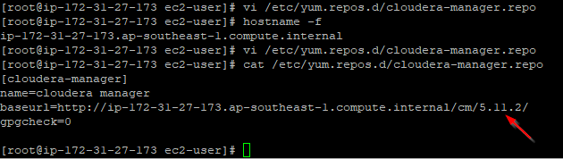

1. Placed the repo file in all the remaining servers
2. Installed Cloudera manager server , deamons, agent in Cloudera Manager Node.

-🡪Created new user ‘mohan’ with password ‘password’ in mysql database

# create user 'mohan'@'%' identified by 'password';

-🡪 Granted all privileges

# grant all privileges on *.* to 'mohan'@'%' with grant option;

# /usr/share/cmf/schema/scm_prepare_database.sh mysql -h ip-172-31-27-173.ap-southeast-1.compute.internal -umohan -ppassword --scm-host ip-172-31-27-173.ap-southeast-1.compute.internal scm scm scm

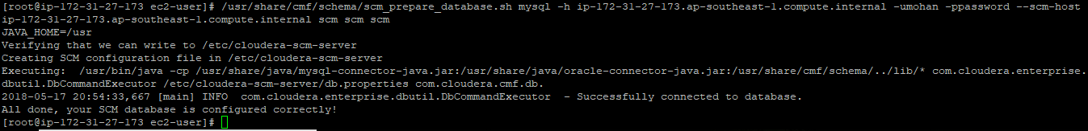

-🡪 Created new database scm in mysql.

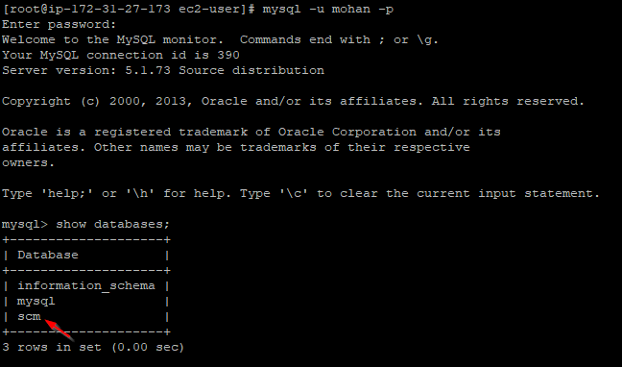

1. and started cloudera-scm-server and cloudera-scm-agent

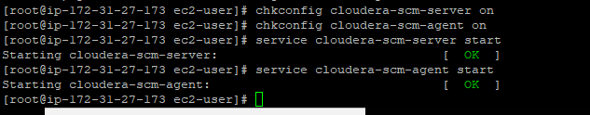

1. Opened Cloudera manager UI in browser

